Things I’m good at
- I have
- I can
Things about me
- I am
How I communicate
- I use

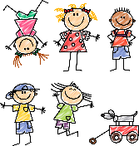



Tricky things
- I don’t like
- It’s difficult for me
- I need you to help me
- I’m still working on
My favourite things
- I like

Things that help me
- It helps me if you
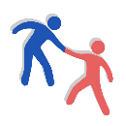
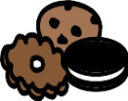

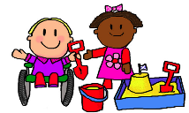
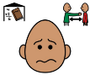



This leaflet was made by X and his/her Mum & Dad with help from XX, XXX School, XXX 2025
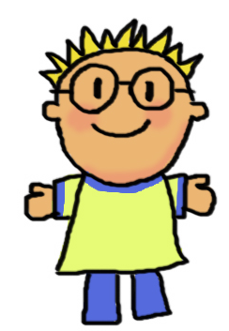
More things you need to know about me

Important people

If you want to find out more about Passports, look up www.communicationpassports.org.uk


If you want to find out more about Passports, look up www.communicationpassports. org.uk

Hi, I’m
X
- I’m x years old
- I live in x
- I have one big brother
- I have two sisters, X and A
- I have an X cat dog called X
- I go to X school
- I’m in PX

